

Case Management Manual

Revised 2-08

Case Management Manual

Overview of Duties:

- Main objective is to process all paperwork relating to application submissions from application to licensing to placing a case in force.

- This is to be done as efficiently and accurately as possible.

- Response turn-around is key! All agent inquiries are to be answered as quickly as possible.

- Tracking of cases and consistent and timely follow ups are critical. There are slight differences in action steps from company to company, but a consistent process is followed for all of them.

- It is imperative that all employees work together and share the work as a team.

Reviewing an Application

- An application enters the building and is given to the case manager to review. Applications must be processed the day they are received, especially if they have a binding check attached. Items to look for:

  - Make sure that paperwork is signed and dated in all of the appropriate places by both the agent and the insured and owner, if different from the insured.

  - Input Upstate’s licensing code and contact info. This information can be found in SO under Insurance Carrier. Choose the carrier and look on the miscellaneous tab. Sometimes the number is hard to distinguish and may also be in the “remarks” section.

  - Licensing should be checked on each agent and if there is a problem or the agent is not licensed, the appropriate licensing employee should be notified to take care of getting that agent contracted with the appropriate company. Currently, this role is handled by Amy Bloom. She will advise whether the app can be submitted or not.

  - The licensing process will be described in a separate section of this manual.

- If an application is submitted to a specific marketing manager, please notify that person via e-mail that the application has been received. They will be able to track the case via SO or may ask to see the file. Be sure and log the case in before anyone else gets the application.

- If you find that an application is incomplete, it must be completed before it is submitted to the carrier. Many times the problem can be fixed right away. Usually, the errors are missing information regarding type of policy, how long of a term, missing signatures, etc. If a signature is missing, most companies will allow a faxed copy so this can be corrected that way. Sometimes the issue has to do with Reg. 60. If the case is a replacement and the proper documentation is not included, the case can not be submitted. If you are not able to resolve the problems, return the application with a written list of issues that need to be taken care of before the application can be submitted again. Generally, any cases received not in good order (NIGO) must be returned within one business day to the agent.

- Once a case has been properly inputted into the computer, the application should be reviewed by a supervisor, all documents and then originals are sent via 2 day overnight to each separate carrier.

- If the application is large, is a special situation, or there are medical issues listed, the application must be give to a supervisor for a cover letter to be written. This allows the underwriter to make a more thorough evaluation.

Forms Necessary for Each Application

- Make sure each application contains the most current and up to date forms. Upstate’s website contains all updated and current forms and the forms can be checked there. An out of date form will be returned to the GA and a new application will be needed. (see notes on incomplete applications) If you are not sure what forms are required, you can find this on our website under the quick links section titled “carrier forms”. There you can choose the company, product, state and will see what forms are mandatory and which are optional.

LIFE APPLICATIONS (highlighted forms are required for all apps):

  - Application including signature page.

  - Agent’s report completed with agent contract number and GA information. At times, there will be more than one agent on a case. The split must be indicated on the application.

  - HIPPA form

  - HIV consent form dated before blood is drawn.

  - Appendix 11/definition of replacement. NY Only (Can not be submitted w/out this form, application will be returned)

  - Temporary Insurance Agreement/ Conditional receipt (if money submitted) Make sure date on check and form match or the money will be returned.

  - Personal information statement (depending on face amount/age of insured – also varies from company to company)

  - Non Medical form (depending on face amt./age of insured)

  - Illustration (with all applications except Term)

Regulation 60/ Replacement Paperwork. NY ONLY

If it is determined that a case is a replacement (this question is asked on every application) the following forms need to be included along with the above documents:

- Authorization to disclose (submitted to replaced company to receive the old policies information)

- Policy information from replaced company.

- Important Notice

- Disclosure Statement (completed after old policy information is received)

Replacement outside NY

Usually just 1 form is needed and it is different for each company and is signed with the application. At this time, nothing prior is needed to be done.

Some companies require additional forms and that can be done on a case by case basis.

1035 Exchange

Forms specific to each carrier are needed to transfer money from an existing insurance or annuity contract into the new contract. If the forms are included in the paperwork submitted, they can be sent to the carrier. If they are not included, then you need to make them an outstanding requirement.

ANNUITY APPLICATIONS

Annuity Applications do not contain as many forms as a life application however the replacement process would be the same.

- Application
- Agent’s report
- Illustration (possibly)
- Check (most every time if not a replacement)
- Appendix 11 (NY)
.

GUARANTEED ISSUE

- *Application
- *Agent’s report
- Check along with Temporary Insurance Agreement.
- *Appendix 11 (NY)
- No medical requirements

APPLICATIONS FOR CHILDREN

- Applications on children are the same as above but children do not need any medical requirements but need a non-medical form.
- If a child is insured via a rider on an adult’s policy, the same requirements apply. (non-med must be completed

DISABILITY INSURANCE

- Disability Insurance is very complex and underwriting is much stricter. Reg 60 requirements do not apply to DI and the applications are not much different, however there are some additional documents needed.

- Income documentation in the form of tax returns, W-2’s, 1040, schedule C, E, or F,

- Group Life and or health insurance are for businesses that want to insure their employees on a group basis. The forms will vary for each carrier and should always be checked with the carrier for accuracy. A census of employee’s is needed, which is a list of all employees’ to be insured. Check this application in with the appropriate BM before sending it anywhere.

- Group Health requires the following forms.

  - Group Master Application

  - membership application and fee
  - Modal premium; at least one month’s premium must be submitted with every application.

  - Enrollment forms must be submitted for each individual employee depending on which special features they want added to the policy.

  - Broker Transmittal

  - Policy information from old carrier which can be a copy of the last bill paid to the old carrier or a copy of the medical card are needed to establish whether this policy will have a pre-existing conditions exclusion.

  - superior service questionnaire

  - Copy of schedule C, E or F.

  - NYS 45s. Two quarters are needed for all company enrollments to establish participant requirements of the employees.

  - IRS form 1045K-1

  - IRS form 1120K-1 or 1120E.

Processing Reg 60 Replacement Paperwork

- When a policy is to be replaced there are necessary steps to take when the old policy is a NY policy. If outside NY there are forms to be submitted with the application, nothing needs to be done prior to submission.

- Authorization Form:

  - This form is faxed to the replaced company on the new companies form. The form contains the old policy number, the insured’s information, the agent’s information, the replacing company, information where to send the policy information, and the signature and date. This form is then faxed to the replaced company and the fax number can be found on the NY Reg 60 website:. There is a link on the Home Office Tools page of the website and you can also save it to your favorites: http://www.ins.state.ny.us/reg60/reg60contacts.htm. NYS companies have 21 days to respond to the request and if they do not comply the application can be signed and submitted.

- When the 21 days are reached and the replaced companies information is received the disclosure statement must then be completed with the old policy’s and the new policy’s information. This is generally done by the agent, although we do assist the agents if requested to facilitate the transaction.

- Important Notice form must be signed and dated.

- The information received from the replaced company must also be submitted so the company can verify where the information on the disclosure statement was obtained.

- 1035 Rollover forms must be completed and submitted if the replaced policy has a cash value that is going to be rolled over into the new policy. These forms vary per company and must be submitted with original signatures.

- All of these forms are required and replacement applications can not be submitted without these forms fully completed with signature and dates (the dates must be after the replaced policy’s information is received). If this process is not completed the agent can be fined a great deal of money. If the paperwork is not complete the application can be held and the medical requirements can be ordered while the problem with this paperwork is completed.

Important information to check for and make sure is included on every application.

- Face amount and plan must be on every application in the appropriate place or the company will not know what plan is being requested and the application will not be bound with temporary insurance. If the premium is not listed somewhere within the application and or illustration a temporary premium can be calculated by running an illustration with an estimate of the insured’s rating. To get an estimate of rating check for any medical questions and age of insured and then run a quote, the agent can also be contacted later to determine exactly what was quoted on the insured.

- A binding check is submitted when the insured wants to have temporary insurance coverage during the application processing time. The check must be made out to the carrier and must be from the insured or a money order. The carrier will not accept a check from the agent, his/her company, or the GA. The check date must also match the date on the Temporary Insurance Agreement and or Conditional Receipt.

- Temporary Insurance Agreement (TIA) Vs. Conditional Receipt. If a check is submitted one of these forms is required. If these forms are not fully completed and the date matches the check the money will be returned and the application can not be bound again until it is placed in force. A conditional receipt is given to the client when they submit their check. If mistakenly sent to the carrier the insurance will still be bound.

- Dates and signatures must be on all forms where required. Almost all forms must be signed by the insured and the agent and sometimes by a witness as well. Usually the signature pages of the application itself require the city and state where the application was signed and this must be present everywhere it is asked for.

- Make sure all questions are answered before submitting any form. All applications contain many questions that must be answered and if the questions are answered before the application is submitted the entire process runs more smoothly. Make sure important information on the insured is complete such as DOB, SSN, age, address, phone numbers, etc.
- Agent’s must be appointed and contracted with each company to get the policy issued. Many companies allow you to submit the application prior to having the agent contracted. When a new application comes in check the advisor’s page under the contract tab to see if he/she has a contract number with that specific carrier. If there is a number make sure the effective date is very recent and if it’s not the company must be called and the number must be verified as active. If there is no agent number for the specific company you are looking for contact the licensing person to take care of getting he/she licensed.

Supplemental forms

- To check for any supplemental forms needed such as the non-medical and the personal information statement use Upstate’s website. In the website use the underwriting tab and select requirements. From here you can choose the company, product, and what type of requirements you are looking for. Underwriting requirements will give a chart of age vs. face amount and will then calculate the specific requirements.

    - Depending on the way the insured has answered questions on the application the carrier may come back and request additional forms such as the alcohol/drug questionnaire form. There are also additional forms for financial justification and other various information the company will request
.
    - Some carriers also require additional forms when the application is submitted and or a different application depending on the face amount of the plan. In this case you can check the required forms on Upstate’s website as well. When logged into the website select the tab for forms and select carrier forms. From here you are able to select the state, company, and product and a list of all their forms will appear. The nice thing about our website is that there will be highlighted forms that are required so you can verify which forms are required with submission of each application.

Ordering Medical Requirements

- Each proposed insured will have to have a full exam and will many times need to have medical records ordered. We use Examone and Portamedic to order medical exams.

- Medical exam requirements are ordered by either the agent or the case manager. On the agent’s report for most carriers’ there is a question asked to the agent whether or not the exam has been ordered already. Make sure to check this before ordering an exam. If the insured’s exam needs to be ordered by you, the case manager, log onto Examone (https://services.examone.com/examone/login/login.aspx?domain=syracuse.examone.com) or Portamedic’s (www.portamedic.com) websites. Once logged on you can order exams and track appointments and completion of exams. Often times you can also get copies of the completed exams directly from the websites.
  - Select order exams and fill in all required information for the carrier, insured, and agent. Age and face amount will determine the requirements needed and each company will specify which requirements have been ordered.

  - If a client is applying for more than one application with the same company the amount applied for will be the total amount of all applications submitted. For example: John is applying to William Penn with 2 applications for face amounts of $100,000 and $250,000. The total amount applied for will be $350,000 and must be entered like that into the appropriate field for the exam. The company will be insuring this total amount so he must have the medical requirements for the combined amount.

  - If a client is applying to separate companies each exam must be ordered separately as the results will go to separate carriers. The client will still be examined for both at the same time however.

  - Make sure to print the confirmation order sheet and keep in the folder of the insured. The exam company will call if there are any problems. Keep track of the insured’s appointment and make sure to obtain copies of all exams completed.

  - The exam company will send all completed medical requirements to the carrier and we are to automatically receive copies of some of the paperwork. We do not receive the actual results of the exam; however we do have to have copies of the Abbreviated paramedical or paramedical exam, the EKG, and lab slip. These will help get the information to the company if there is a problem.

Ordering APS or Attending Physician Statement/ Medical Records

- We use RSA Medical to order all APS’s. There website is http://www.rsamedical.com/home/default.asp and once logged in (currently it is: user name: eminier and password: 1124) you can order and track medical records.

- To order medical records select Order APS. On the new screen you will select the carrier that the insured has applied to always leave dates at any and all. There is then a place for any special requests if there is specific information you need from the doctor. Continue to fill in the insured’s information and all that is required are the red starred items. The doctor’s information is last and you will need to have name, address, and phone number as it is very hard for RSA to locate the correct doctor without that information.

- Select submit and a new screen will appear with the order information. At the bottom right hand side will be a sentence to print the fax cover sheet and when located with your mouse can be clicked on. This fax cover sheet must be faxed in immediately after the APS is ordered with the HIPPA form attached as well. Without the HIPPA the records can not be received from the doctor.

- Sometimes doctors will request additional signature authorization forms specific to their office in order to receive the records. If this is the case RSA will send you an email with the new form and you need to contact the agent to get this new form signed and faxed back to RSA. The form will be encrypted with a password that will be the last 4 digits of the insured’s SSN.

- You can track the progress of the records by logging into the website and typing in the client’s name. When the records are received you will get an email with the records attached. They will be in PDF format and encrypted with a password that is your password to the website.

- All records must be printed out if full and sent to the carrier. A copy must be kept for the file either electronically or in paper format.

- Sometimes the carrier will order the APS and this varies from carrier to carrier. Before ordering an APS through RSA verify that the carrier has not already done so. If the carrier does order the APS,

- keep track of the progress and make sure you know when the carrier receives it.

Procedures for Setting Up New Agents with our website
and with Smart Office

- First, the agent must be set up for access to our website.

  - Using “Remote Desktop Connection”, go to www.e-upstate.net.
  - The Login page will have the name “Laura” the password is “Legs”
  - Once in, there is an Access database where you will put the name, user name and password
  - Last name, First Name; Password is first initial, last name and Password is generally the assigned agent number from Smart Office. You can also use the last 4 digits of the social security number if you have it.

- Once an application has been received, we will then provide access to SO for Advisors

- First step will be to send an e-mail to the agent letting him know that he is being given access to our online case status and he will be receiving another e-mail shortly with a link to the site, plus a user name and temporary password.

- Follow Smart Office Procedures for setting up an advisor for access which are as follows:

  - Find Advisor in the Quick Search Box
  - Open advisor’s page
  - Go to >> which drops down a menu – Choose “SmartView for Advisor User Management
  - You will be given three choices – Create, Delete, Generate Password. Choose “Create”
  - Here you will change the computer generated name to their first initial, last name and click okay
  - An automatic e-mail will be generated and sent to the agent, as well as the administrator with the link to Smart Office, their user name and a temporary password.
  - The administrator will post the e-mail received with the login info to the advisor’s page so that you will have access to it.
  - Last, but not least, you must again to the drop down menu (>>) and choose “Assign contacts to the current advisor”. The system will let you know when this process is complete

ENTERING AN APPLICATION INTO SMART OFFICE

- From the side menu, click Pending Case and then select PCM Search from the expanded menu to open the Search Pending Cases dialog box. 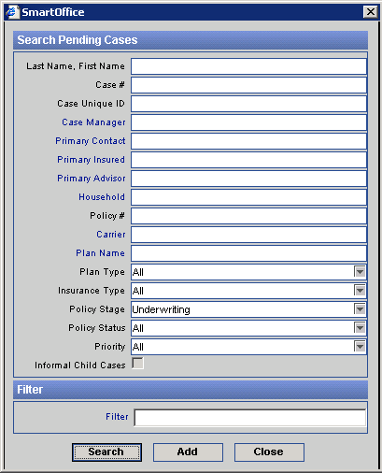
Click the Add button to open the 1st PCM Add dialog box.
- Select the Formal Application Type, specify the Product Options and Insurance Type and then click the Next button to open the 2nd PCM Add dialog box.
- Enter the Basic Policy, Insured, and Advisor information
- The information that is required will highlight yellow if you don’t fill it in before hitting finish.
- When typing in the insured’s information you can use the ‘Lookup’ button to search the database to see if the insured’s contact record already exists. If it does you can use it to continue on. If it doesn’t you must continue filling in all of the information and then use the ‘Add’ button to create a new contact record for this insured. Make sure you enter all necessary information to the contact, including the primary advisor, address, and phone number (you may have to do this after completely adding the pending case).

- When typing in the premium information you must make sure what type of application you are entering so the premium information and commission information is entered correctly. Follow the below rules for entering all premium information.

  - Term Application: Modal prem; Prem. Mode; pay method. Comm. Annlzd will be calculated automatically.
  - UL/SUL Application: prem; Prem. Mode; pay method. Comm. Annlzd will be calculated automatically. Also target must be entered and this can be found on the illustration submitted.
  - UL/SUL with 1035 or lump sum: prem; Prem. Mode; pay method. Comm. Annlzd will be calculated automatically. Also target, lump sum or 1035 amount, and excess must be entered. Target can be found on the illustration submitted. Lump sum or 1035 amounts are also on the illustration. Excess must be calculated; it is the total amount of money coming into the policy the first year minus the target.
    - Example 1: 1035:25,000 - Target is 450,000 = excess 425,000. Example 2: 1035:25,000+ 1st yr premium $5,000 – Target of 450,000 = excess 420,000.
  - Annuity Application: Modal Prem.; Prem. Mode; and Pay method are entered by you. Comm. Annlzd must also be calculated by you, therefore check the ‘Do Not Calculate’ box and enter the Comm. Annlzd which is 1% of the annual premium.
  - Also don’t forget the beneficiary’s and owners if there are any. When the insured is added the owner information automatically generates, however it may be different so don’t forget to double check. Up to two contingent beneficiaries are able to be entered and also collateral assignments are a possibility.

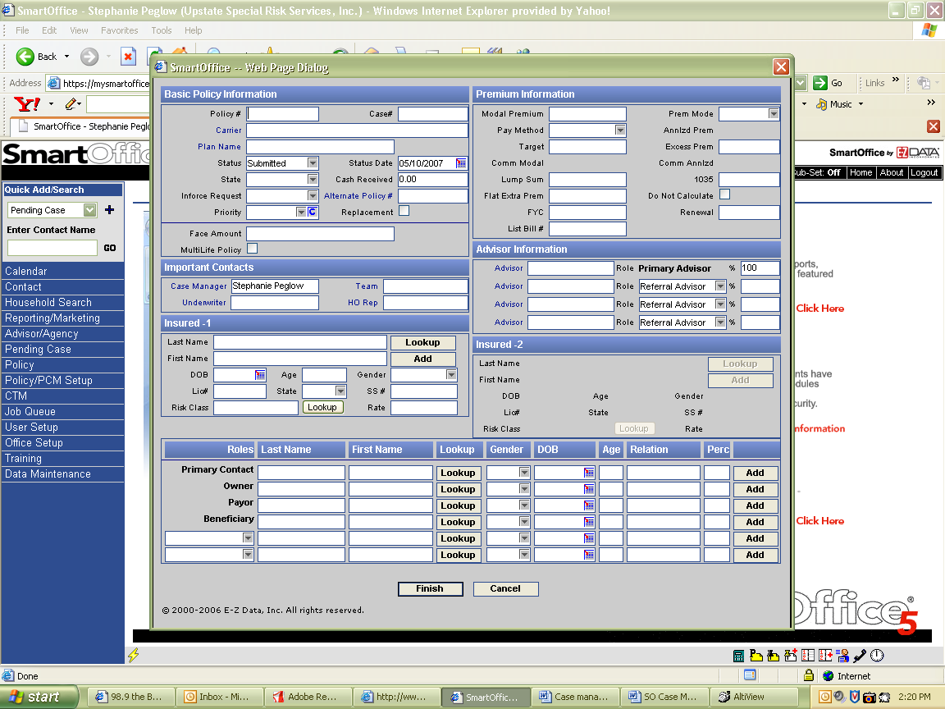
Click finish

The pending case screen will now appear.

- Underwriting requirements must now be added. Most carriers have automatic underwriting requirements and they will automatically generate. Make sure they are correct and verify the follow up dates, the status, the completed date if there should be one, and any description on the requirement.

- If the requirements are not automatically generated.
- Click the Add button to display the Select Requirement Type dialog box.
- Click the Manual hyperlink to open the Underwriting Requirements dialog box.
- Enter the Underwriting Requirement information (selection of a Contact is mandatory) and the Description of the Requirement that will display in the Underwriting Summary.
Note: For entering multiple Manual requirements, separate the descriptions by two hyphens ‘--‘ (e.g., For a Manual requirement, enter the Description as ‘Blood Profile -- HO’, when the Underwriting Requirement dialog box is closed, the requirement saves as two stand-alone requirement entries with their own descriptions).
  - Click the OK button to save the information to the Underwriting Requirement Summary.
  - A letter must then be sent to the Advisor and the carrier to advise them both of the new application. On this tool bar there is the icon that looks like a letter and that icon is always used to send a letter. When you click this icon, a new screen will appear with a list of people who you could potentially send a letter to. Check the people you would like to send a letter to, you can send multiple letters by checking multiple names. Then click ‘OK’.
  - The next screen that appears will be a list of potential letters. When adding a new case the new application letter gets sent to the carrier and the acknowledgement formal gets sent to the advisor. When the letter is chosen it will appear in SmartLink for Word and you will be able to make changes. Select ‘view’ ‘normal’ to modify the letter and when finished click the ‘save and close’ button. One more box will appear asking you to continue and the letter will either print or email.
Documentation and Communication with the agents and carriers

- Documentation is critical to the success of the application and the relationship you have with the agents and carriers. Sometimes problems will occur when documentation of prior conversations and tasks completed is the only thing that will solve the problems. The following information must be done at all times.

- The agent must be kept in the loop of the application and pending process of each application. The carrier and the case manager are in contact all of the time and if things are running smoothly the agent can very easily be left out. To keep the agents in the loop make sure to send him/her status emails and letters at least once a week.

- Whenever a new requirement is needed or received by you or the carrier the agent must be notified by letter or email. The toolbar where the letter icon is also contains the email icon. When this icon is selected a screen will appear asking who you would like to send an email to and a new email message will appear. Type your message and when send it clicked a dialogue box will ask you to link the email, always link the email to the appropriate person in Smart Office.

- When a requirement is needed from the agent a personal email or phone call is often necessary to make sure he/she knows what is needed and that the item is very important. Use either the email icon or call the agent. If a call is made make sure this call is also documented in the Smart Pad.

- Document all correspondence by always either using the email system directly built into each individual case or by copying your emails into each case’s SmartPad section. When you receive an email about a case the email can be automatically linked into the SmartPad by using the SmartMail button in Outlook. You will be prompted to pick the appropriate contact and then the email will be linked to that contact’s SmartPad.

- Check carrier websites and or downloads into each case on daily basis to make sure no requirement is left unattended for any period of time.

- Many companies will have to be contacted if a requirement is not taken care of and often times a phone call to them speeds the case along.

- Be sure to document any email and or correspondence in the system and keep any paper documents in the file.

- All new requirements must be added into the system on the underwriting tab and a follow-up date must be created to remind you to check on the requirement.

- If a requirement has been followed up on a quick note next to the requirement is all that is needed often times. For example: Non medical form is outstanding agent. It has been outstanding since 2/1 and on 2/9 I called to remind the agent. Next to the requirement add a note that states “2/9 reminder to agent.” This allows all people viewing the case to understand that everything is up to date. Also that reminder will be documented in the Smart Pad to verify it was in fact done.

- Good relationships with the companies and having key contacts also helps a case get completed quickly. Make sure to keep the companies in the loop as well if you have been waiting for something and they have been too.

- Many companies can be emailed requirements as well as faxed and some can only accept faxes. It varies from company to company.

Approval, declinations, and postponements

- When an application is approved the carrier will notify you with the approval and sometimes the reasoning for an adverse decision. On occasion the approval will not be sent directly to you and you must have accurate follow-up dates to make sure you look for the approval in a timely fashion.

- When approved the approval must be documented in SO. The outstanding underwriting requirements must be made received, the case status must be changed to approved, a requirement for a policy must be added, and the agent must be notified of the approval.

- Any approval must be reviewed by the BM to make sure it is valid, unless it is approved as applied for. When the review is completed a letter must be sent to the agent with the approval, reason for approval, and new premium.

- When an application is declined the company will contact you with a reason for declination, most of the time. The reason must be reviewed and verified if it is a valid reason or not. This procedure is done by the marketing manager. The agent must then be notified of the declination.
- When notifying the agent care must be taken in what is said to the agent. The agent is not allowed to know specific medical information about his/her client. The agent is allowed to know general reasons for declination and if they request more in depth reasons they must request that information from the carrier.

- A letter can be sent to the carrier signed by the insured asking them to send all lab results that lead to the declination.

- When this is done the case is out of our hands. If the case is reopened later that is treated like a brand new application.

- When an application is postponed, the carrier will contact you with reasoning for postponement. The reason must again be reviewed, however, in this case the case can be reopened once the reason for postponement has been resolved. Contac the agent and explain to them the situation and tell them what needs to be done to complete the application.

Policy Issue

After an application is approved the policy will then be issued and sent to you. If the policy is not sent in a timely fashion, 3-4 days, make sure you follow up with the carrier to see what the hold up is. When received the policy must be reviewed CAREFULLY with the information you have in the system and file and all pertinent forms must be copied along with page 3 of the policy and placed into the file. The forms must be recorded into the system and requirements placed outstanding and the policy sent to the agent to get delivered and signed.

- In SO receive the policy requirement and then place the status of the case to issued. A new screen will appear at this time to add all of the new policy information. Verify all information, including premiums and dates. Then add the delivery requirements.

Adding Delivery Requirements
Adding a Manual Delivery Requirement

- From the side menu, click Pending Case and then select PCM Search to open the “Search Pending Cases” dialog box.
- Enter a value in one of the available fields and then click the Search button to open the Pending Case Summary list.
- Tag the appropriate pending case record and then click the Delivery tab.
- Click the Add button in the Delivery Requirement Summary section to open the “Select Requirement Type” dialog box.
- Select the requirement type to open the “Select Requirements” dialog box.
- Click the Manual hyperlink to open the Delivery Requirements dialog box.
- Enter the Delivery Requirements and a description of the requirements.
- Click the OK button to save the information in the Delivery Requirement Summary

To Modify Delivery Requirements

- From the side menu, click Pending Case and then select PCM Search from the expanded menu to open the Search Pending Cases dialog box.
- Enter a value in one of the available fields and then click the Search button to open the Pending Case Summary list.
- Tag the appropriate Pending Case record and then click the Delivery tab.
- Click the appropriate Insured Name hyperlink to open the Delivery Requirement Details dialog box.
- Make the modifications and then click the OK button to save the changes and return to the Delivery tab.
  - Keep track of the delivery period as to not let it expire.

  - If the agent and the client review the policy and find anything wrong or want to change anything the policy can be reissued.

  - Contact the company with the changes to be made and have them reissue the policy. The original policy will have to be returned and the issue process must be done all over again.

  - Face amount can be reissued without underwriting if the new amount is lower than the original amount.

  - Depending on the change requested, it will have to be determined if it can be done or not and this varies case by case. The company will probably have to be contacted.

Policy Placement

- When policy delivery requirements are received they must be reviewed for completion and the requirements must be verified against the company’s requirements as to make sure all requirements are received. When money is needed to place the case, even having any other delivery requirements will not put the case in force. A case can not be placed without the money. When all requirements are received the case can be placed and is finally out of your hands.

- Complete the delivery requirements and send them to the carrier. Add a delivery requirement called ‘commissions due and payable’ and put the follow up date two weeks later and make the requirement manager for this requirement the commissions person.
- The case status must then be changed to in-force and a letter with the delivery requirements must be sent to the carrier.

Day to Day Activities

- Each day there are a number of activities that must be completed to be sure that each case has all requirements accounted for and the case is running smoothly.

  - Check downloads from each company and websites on a daily basis. Many nights companies update their information so there is new information being added onto cases all the time.

  - Update each case daily with any information received from agents and the medical companies regarding requirements.

  - Run the pending list every other day and make sure it makes sense to you and anyone else reading it.

  - Requirements that are outstanding on the pending list should be followed up with every other day unless otherwise specified on a case by case basis.

  - Forms needed to be signed can be given more time as the agent must have time to get the form signed by the client as well. Make sure however to check for deadlines on forms as these deadlines must be strictly followed.

  - Approval’s and underwriter’s review usually take 4-5 business days so follow up on these requirements on that basis.

  - Delivery requirements can be given about 2 weeks before the first follow up is needed. Make sure that as the deadline for delivery requirements draws closer more reminders are sent to the agent.

      - If the agent notifies you that the delivery period isn’t going to be long enough an extension must be requested.

  - Check the fax machine regularly throughout the day for any notices from carriers and or agents.

  - Remember to document and keep the agent updated on everything. The rule is if an activity occurs on a case, send the agent a status.

